Nepal College of Information Technology
Unit Test
Spring 2010
Program : BE IT Time : 2 hrs
Semester : Spring (II) FM : 70
Subject : Network Theory PM : 35

- Candidates are requested to give their answer as far as practicable in their own words.
- The figure in the margin indicates the full marks
- Attempt ALL question
1. a) In the figure given below, switch k is at position 1 initially. After the steady state condition has been reached, switch is changed to position 2 at t=0. Using time-domain method, find the expression for i(t). 8
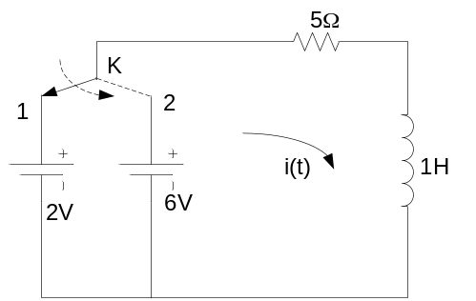
b) The figure shows a first order RC circuit with initial voltage of 10V stored in the capacitor at polarities shown, find v(t). Switch is closed at t=0. 7
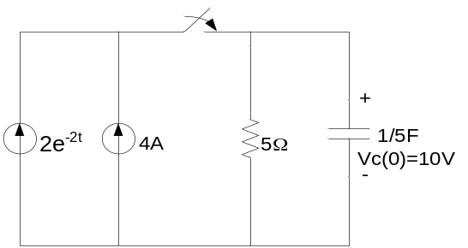
2. a) In the given circuit, switch k is changed from position 1 to 2 at t=0, the steady state having reached previously. Find the values of i, di/dt, d²i/dt² at time t=0. 7
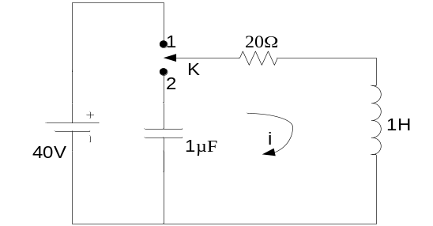

b) The figure below represents a parallel RLC circuit where R=0.1Ω, L=0.5H and C=1F. Capacitor C has an initial voltage of 5V. The switch is closed at time t-0. Obtain v(t). Use classical approach. 8
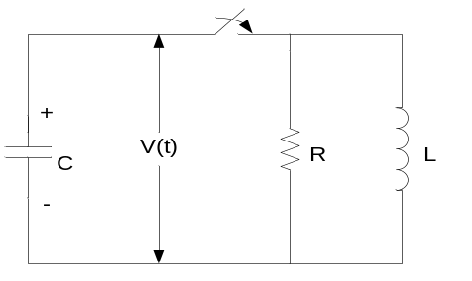

3. a) An exponential voltage v(t)=5e^{-t} is applied at t=0 to a series RC circuit having R=5Ω and capacitor C=0.1F. Using Laplace transformation, obtain the complete solution for current i(t) through the circuit. Assume zero charge across the capacitor before application of the driving voltage. 7
b) In the series RLC circuit, V₀= 8V, L=1H, R=3Ω and C=0.2F. Switch K is closed at time t=0. Obtain the particular solution for current i(t) through the series circuit. Assume Zero current through inductor and zero voltage across capacitor before switching. Use Laplace transform. 8

4. a) Find the driving point impedance of network shown in figure below. 7
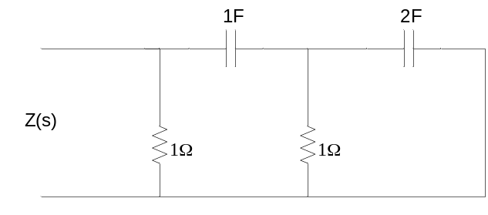
b) Apply Routh Hurwitz Criteria to the following equations and determine the number of roots having positive, negative and zero real parts. 8

5. a) Find the Fourier Series of the function shown below. 7
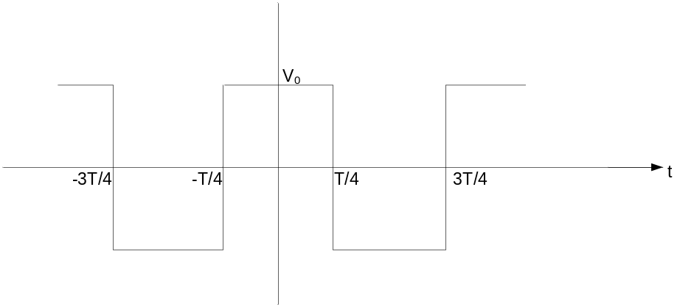
b) What is time constant of RC circuit? Explain with necessary derivation and curves. 3

